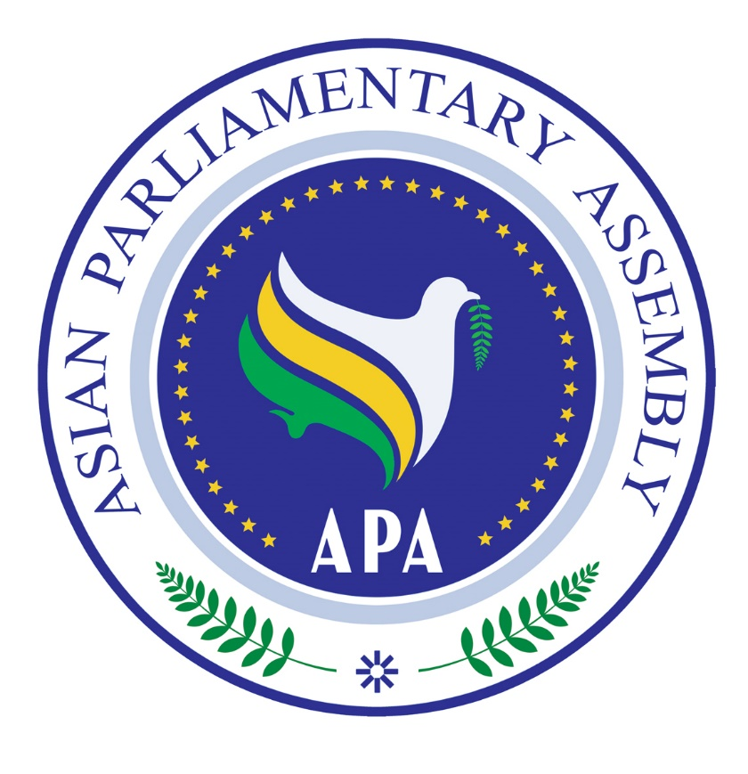
Agenda of
"APA Coordination meeting in the sideline of
139th IPU Assembly"
Sunday, 14 October 2018
Geneva, Switzerland

(6 October 2018)
Time | Subject
10:00-10:10 | Hon. Mr Binali Yıldırım, President of APA, "Welcome Speech"
10:10-10:20 | H.E. Dr. M.R. MAJIDI, APA Secretary General, “ Report of APA activities 2018-19”
10:20 -10:30 | Announcements by:  _Delegation of Senate of Pakistan  _ others
10:30 -11:15 | IPU Emergency Items
11:15- 12:00 | Any other Matters
12:00 | Closing.

